Design outline:

Step 1: Ask customer if they want a yard or house cleaning service, reject all other inputs

Step 2: Based on step 1 entry, run either a house cleaning or yard cleaning function

Step 3: Both house/yard functions have lists of appropriate sub services.

Step 4: Pass these lists to a get input function. This function will get input from the user for specific services they request and ensure they’re on the list of appropriate services. This function will reject any invalid inputs. This function will also ask for different inputs depending on what the customer has already answered, for example it will only ask house related questions if they ask for a house service, and will only ask information about the yard footage if they ask for mowing etc.

Step 5: After the inputs are all stored, two cost calculation functions will add up all the services requested by the user, one function for house and one for yard. This function will take into account variables such as sizes of the house, sizes of the yard and scale the cost appropriately.

Step 6: After the cost is calculated, a senior citizen function will reduce the cost of the services by 15% if the user enters that the services are requested by a senior.

Test plan:

1: Test any invalid inputs are rejected and user is prompted to re enter valid inputs

2: Test the yard calculations are all correct

3: Test the house calculations are all correct

1:  
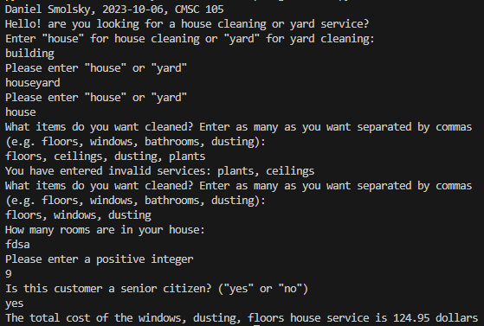

2:

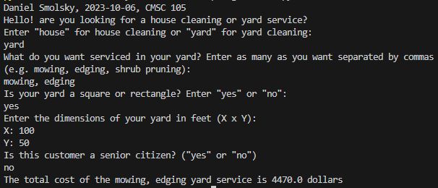

3:

